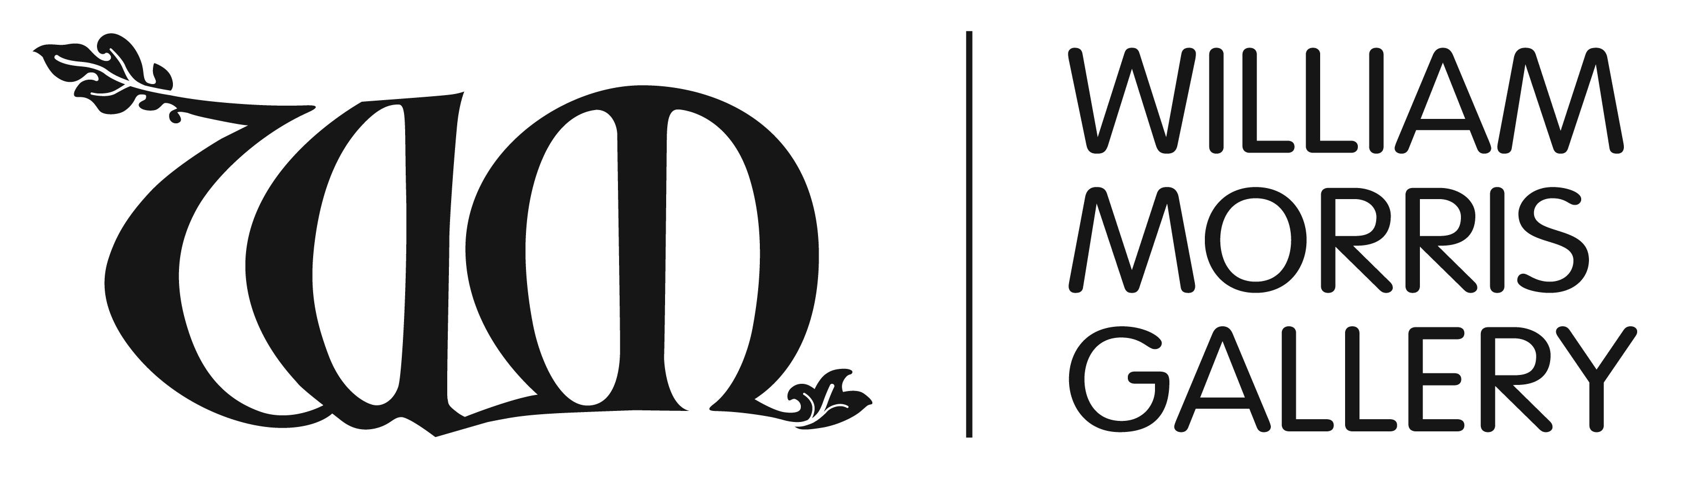
William Morris Gallery Learning Resources

TOPIC NOTES FOR TEACHERS

1: Inspiration from Nature

These topic notes provide broad contextual information for teachers and older students. They provide further information to support the Key Stage 2 gallery activity sheet and also to support classroom study. The content in this topic will be a useful context for art and design projects using natural forms as a starting point and can be adapted for either the primary or secondary curriculum.

William Morris (1834-96) is chiefly known as a great Victorian designer of patterns derived from natural forms. Wild and garden flowers, intertwining leaves, birds and animals all feature in his wallpaper, textiles, carpets and ceramics.

This topic features:

Why nature was so important to Morris:
i) Boyhood love of the Essex countryside
ii) ‘Truth to nature’: Morris and the Pre-Raphaelites
iii) Nature and beauty
iv) Simplification and abstraction: balancing realism and design
How Morris used drawing and developed his designs:
i) Morris’s own drawing skill
ii) Drawing style for designing
iii) The idea comes first
Follow-up project: designing from natural forms

MORRIS’S RELATIONSHIP TO NATURE

‘When we can get beyond that smoky world, there, out in the country we may still see the works of our fathers yet alive amidst the very nature they were wrought into, and of which they are so completely a part.’ From Morris’s lecture: The Decorative Arts

i) Boyhood love of the Essex countryside

Morris’s love of nature developed in his early years. In 1840 when Morris was six, his family moved to Woodford Hall, a large country house with 50 acres of parkland next to Epping Forest. Morris as a young boy spent many hours exploring the Essex countryside on his pony and visiting ancient local churches.

At Woodford Hall, each of the Morris children had their own small garden to tend. Morris was fascinated by the different plants and flowers and knew many of their names which he studied in an ancient Herball (a book about plants) written in 1636 by John Gerard and kept in the family library. The Herball was full of beautiful clear line drawings of plants with descriptions of their particular properties.

The family moved to Water House in Walthamstow (now the William Morris Gallery) in 1848. The grounds, particularly the moated island (which you can still see) and the kitchen garden made the
greatest impression on the young William Morris. The brothers fished or swam in the moat and the island was ‘a sort of fairy land for all the children who almost lived on it’. [Morris letter]

Although Morris moved away later, he never lost touch with the area and as an adult was involved in campaigns to preserve Epping Forest against encroaching industrialisation.

ii) ‘Truth to nature’: Morris and the Pre-Raphaelites

For many artists in the first half of the 19th century, the idea of nature represented truth and beauty – a purity and spirituality which they believed the modern Victorian age had lost. This was largely a response to the ugliness of rapid industrialisation: the growth of huge factories – those ‘dark satanic mills’ as described by William Blake – and the appearance of vast areas of slum housing.

In his book Modern Painters (1843), the influential act critic John Ruskin advocated that ‘Truth to Nature’ should be the primary role of the artist. This also became a central principle of the Pre-Raphaelite Brotherhood founded in 1848; a group of young men eager to renew the arts of their time and rebel against the establishment. Their early paintings paid close attention to natural detail, for example, to paint Ophelia (1851-2), John Everett Millais stood for hours near a stream in Surrey painting the flowers and plants by the riverbank in intricate detail. Pre-Raphaelites admired the art of the Middle Ages (i.e. before the time of the painter Raphael), seeing it as a Golden Age, before industrialisation. Art of that time was regarded as purer and more authentic with the use of bright colours and clear simple forms.

Morris became associated with the Pre-Raphaelites around 1856, mainly through his friendship with the painter and poet Dante Gabriel Rosetti. Rosetti, along with Millais, William Holman Hunt and Ford Madox Brown were the key founding figures of the Pre-Raphaelite movement. Morris met Rosetti through the artist Edward Burne-Jones, his best friend at Oxford University. Burne-Jones and Morris also developed a great love of Gothic art and architecture. Morris particularly admired the medieval use of plants and animals in decorative details. However, Morris was to take a much more selective designer’s eye to nature than the original Pre-Raphaelites ‘paint every single blade of grass’ approach.

iii) Nature & beauty: What is ‘beautiful’ in decorating your house?

‘I think it will be enough for us to clothe our daily and domestic walls with ornament that reminds us of the outward face of the earth, of the innocent love of animals …’

William Morris wanted everyone both rich and poor to enjoy beauty in their everyday lives and to be able to make their living environment beautiful. He said ‘it would not do to have all the “Best Art” as decoration’ (that is lifelike figure or narrative paintings representing stories of mankind’s heroic hopes and tragedies). There is a limit to how much we can have our emotions moved and stirred and we certainly wouldn’t want to look at paintings like these all the time. Therefore for Morris the ideal forms of decoration are ‘soothing and restful’. He warned that too much ‘scientific representation’ would ‘involve us in the problems of hard facts and the troubles of life’.

iv) Simplification and abstraction: balancing realism and design

Morris was very clear that best kind of decorative art ‘must be suggestive rather than imitative’. He was critical of over-elaborate contemporary designs, for example wallpapers that tried to create a lifelike illusion of a bunch of flowers through use of shading. For him it was essential that the design reflected the flat quality of the surface it was designed for, that no one element caught too much attention or made one think too hard.

‘Is it not better to be reminded however simply of the close vine trellis that keeps out the sun by the Nile side; or the wild woods and streams with the dogs panting beside them … or the many flowered summer meadow in Picardy?’

‘Is not all this better than having to count day after day a few sham-real boughs and flowers causing sham-real shadows on your wall with little hint of anything beyond Covent Garden in them?’ (A reference to Covent Garden as a former fruit market)

However, he did not want decorative designs to become purely abstract. Although he admired the more abstract geometric designs of Islamic art he stated:

‘I must have unmistakable suggestions of gardens and fields and strange trees or I can’t do with your pattern … You may be sure that any decoration is futile … when it does not remind you of something beyond itself, of something of which it is but a visible symbol.’

THE ROLE OF DRAWING AND DEVELOPING DESIGN IDEAS

Morris developed his design ideas from looking carefully at nature and from a deep knowledge and understanding of how different plants and species work.

i) Morris’s own drawing skills

We don’t have examples of sketches he did from direct observation of nature but we know that he did a lot of drawing. While working for George Street’s architectural practice briefly after finishing at Oxford, he vowed ‘to get in six hours drawing a day on top of office work’. Here he would have learned to do detailed and clear design-style drawings.
Initially Morris lacked confidence in his own drawing skills. You can see these develop by comparing his early self-portraits in 1856 (in the entrance of Gallery 2) to more assured figure studies in the late 1850s after he attended some drawing classes.
For his first wallpaper design Trellis (1862), he asked his friend and colleague at George Street’s practice – Philip Webb – to draw the birds. He also used Webb’s highly-detailed drawing of a hare as the basis for the hare in his Forest tapestry of 1887.
ii) Drawing style for designing
Morris said that all design drawings should be made with good clear outlines and avoid vagueness. ‘Do not involve yourself in a tangle of poor weak lines that people can’t make out ... If you have any inclination towards that short hand of picture painters which they use in a hurry, and which people call sketching, then give up pattern making for you have no use for it.’

iii) The idea comes first
Morris said it was hopeless to take ‘a natural spray (i.e. branch) of whatever and torture it into certain lines’. He was clear that in the design process the idea should come first – for example, if someone says ‘I want to make a pattern that will give people an idea of a rose hedge with the sun through it, and he sees it in such a way … then and not till then he sets to work to draw his leaves, his thorns ... and so carries out his idea.’
iv) The role of observational drawing
Therefore the image or idea needs to be distilled in the designer’s head through an initial process of observation, drawing, planning and selecting of the elements he/she needs. Morris seems to have had a particular ability to distil ideas into pattern without apparently going though initial stages of observational drawing – the only evidence we have are little marginal doodles of daisy clusters on the edge of a business document.

FOLLOW-UP PROJECT: DESIGNING FROM NATURAL FORMS

Undertake a range of studies from life in different media, for example, pen and ink, pencil, charcoal, crayon. Consider creating a design for a specific purpose, for example, tile painting, wallpaper, fabric for curtains, for chairs. What sort of design would work best for different purposes, for example, scale or complexity?

Use viewfinder windows, photocopying with heightened contrast, collage versions to identify bold simple shapes that would work well as a repeated design.

Develop a repeating design using graph paper. Work out a three-colour version.

